Founded in 1989, NTT DATA Business Ganesh Solutions currently has more than 12,000 employees providing services in 30 countries around the world. Our Managed Services resources are some of the most experienced SAP consultants in the industry. The diagram illustrates our performance over the past 5 years. In 2021-2022, NTT DATA Business Solutions posted annual revenues of 1.2+ Billion USD.

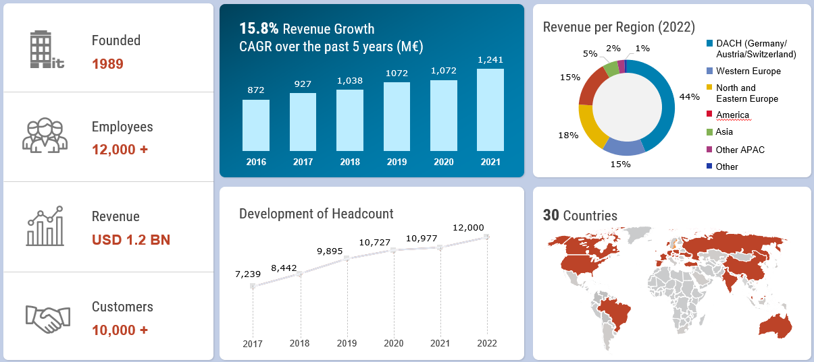

Corporate Facts and Figures

NTT DATA Business Solutions falls under the NTT organization, which is the third largest telecommunications company in the world headquartered in Tokyo, Japan. This organization structure provides our company a remarkable capability to scale and to serve companies such as Columbus McKinnon with experienced resources and product experts. Further details concerning the NTT Corporation structure, alignment of NTT DATA Business Solutions within the overall corporate organization, and overall NTT company performance and global presence can be seen on the following graphics.

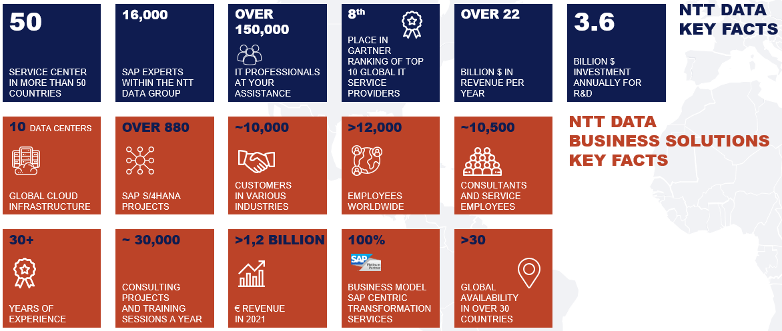

S/4HANA Experience

NTT DATA Business Solutions has over 800 S/4 HANA Projects and boasts over 1000 HANA Database clients across a variety of SAP’s software product portfolio. As early adopters of S/4, our consultants began practicing on S/4 early and its adoption has been a mainstay for almost 10 years. We expect all of them to be considered S/4 resources.

NTT DATA Business Solutions | Global SAP HANA (S/4HANA) Expertise and fast adoption

## 